Dear Resident,

In this newsletter we confirm the date for David Burrowes’ Cycle Enfield meeting at the Christian Revival Hall; report on coverage of Cycle Enfield in the media; bring you news about the Palmers Green and Town Park Festivals; provide a glimpse into the future if Cycle Enfield is implemented; give a link to the report that challenges the legitimacy of the Enfield West consultation; and give an update on the book club.

First, a reminder that our MP David Burrowes will be seeking your views about the Cycle Enfield proposals for roads in Enfield Town and along the A105 (Green Lanes from the Dugdale Centre to Palmers Green) at a series of meetings in September. David has arranged three meetings to give residents the opportunity to discuss the Cycle Enfield proposals for the A105 and Church Street and Cecil Road in Enfield Town; the one closest to us will be held on MONDAY 28TH SEPTEMBER at 8pm at the REVIVAL CHRISTIAN CHURCH on London Road (next to the Catholic Church, a couple of minutes from the Dugdale Centre). The two other meetings will be on the 17th September at 8pm at the United Reformed Church, Compton Rd, Winchmore Hill and the 22nd September at the Intimate Theatre, Palmers Green, again at 8pm. PLEASE TELL YOUR FRIENDS, RELATIVES AND NEIGHBOURS IN THE WARD ABOUT THESE MEETINGS.
The meeting at the Revival Christian Church has been scheduled to follow the Cycle Enfield exhibition days at the Dugdale Centre on the 25th and 26th September (for residents; 24th for businesses) at which the proposals for Enfield Town will be displayed prior to Enfield going out to consultation on this part of the scheme. David and our councillors are aware of the very great dismay of local residents at the Council’s proposal to close Church Street to cars and double traffic on Cecil Road and has convened these meetings to so that he can hear your views – please do make every effort to come along so that he can send a strong message back to the council and to TfL, the funders of the scheme.
Media coverage. Cycle Enfield got quite a bit of media coverage last week following publication of a press release written by Linda Miller, Helen Osman and Costas Georgiou. First our thanks to Charlie Peat who wrote a great article about residents’ and businesses’ concerns about the plans for Church Street and Cecil Road which not only made the front page of the Enfield Independent but also the Ealing Times! If you didn’t get a copy of the Indy this week you can read the article online at: http://www.enfieldindependent.co.uk/news/13611091.Outrage_surrounding_Enfield_Town_cycling_plans/ The story also got picked up by London Live TV and on Tuesday Helen Osman (Save Our Green Lanes) Linda Miller (ETRA) and Paul Mandel (Save Our Green Lanes) were interviewed on the London Live lunchtime show about the likely impacts of the Cycle Enfield scheme along the A105 and in Enfield Town; Cllr Daniel Anderson was also interviewed. We pointed to the problems the proposed changes would bring in terms of increased congestion and the difficulties for businesses in getting deliveries and argued for an alternative route; Cllr Anderson said it was all part of a push to deliver ‘a modal shift in transport’, showing the council’s real grasp of the realities of business life in the borough...
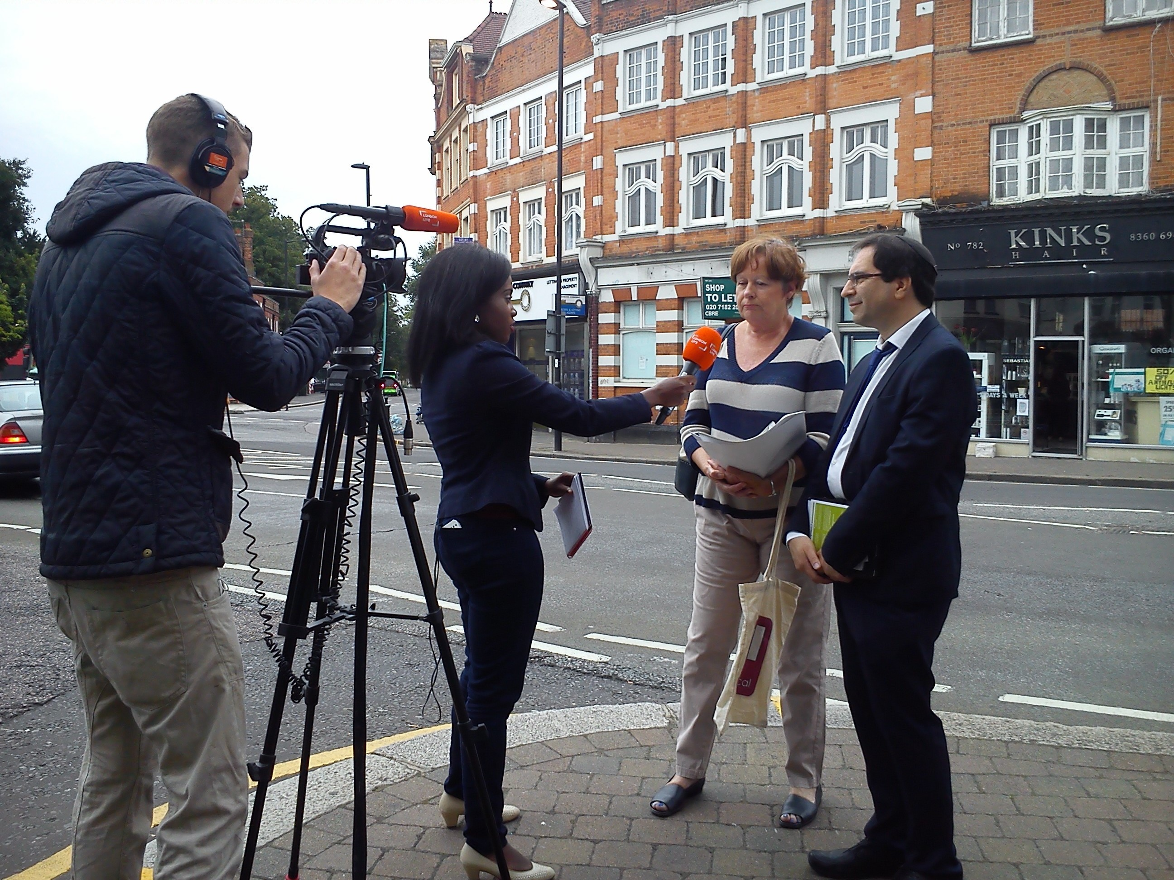
Picture shows Helen Osman and Cllr Daniel Anderson being interviewed by Vanessa Baffoe on London Live TV
Palmers Green and Town Park Festivals. Save Our Green Lanes will have a stall at the Palmers Green Festival on September 6th at Broomfield Park with ETRA also in attendance – please come along and say hello if you’re at the festival. We are starting a ‘Save Our Enfield Town’ campaign in parallel with the A105 campaign and will be selling plants in support of the Save Our Green Lanes and Save Our Enfield Town campaigns at the Palmers Green Festival on the 6th and the following weekend (12th and 13th) at the Town Park Autumn Show. If you have any plants or other items you can donate in support of the campaign please email us at ETRA and we will arrange to come and collect them – thank you! Also, if you are willing to spend an hour or so at the stall on either weekend telling people about the problems the proposals for Enfield Town will bring for residents, please get in touch so we can confirm a time for you to attend. Many thanks!
A glimpse into the future. Walthamstow were also awarded money under the Mini-Holland fund and are a few months ahead of us. If you want to see the true chaos that Andrew Gilligan is happy to see inflicted on London residents – and get an idea of what emergency service vehicles will have to deal with in Enfield if the current Cycle Enfield plans are implemented, take a look at this website set up by residents in Walthamstow: https://www.facebook.com/pages/E17-Streets-4-All/1534620430138233
Challenge to the current Enfield West (A105 – Green Lanes) consultation. As we said in the last newsletter, Grange Ward Councillor Terry Neville has written to Enfield Council raising serious concerns about the flaws in the Council’s documentation and demanding that the consultation be stopped until these flaws are addressed. The analysis of the flaws has now been published and you can see the report here: https://drive.google.com/file/d/0B6ALBbxYFMmnV3NsOE4zR0RDaVE/view
Book Club. You may recall that we had hoped to get a book club off the ground. June, who was leading on this development, suffered a bereavement which understandably meant that she was unable to give the book club the time and attention needed to get it up and running. June apologises for the delay and is now hoping to get back onto this shortly and will be contacting those of you who expressed interest in this earlier in the year.
At some point we hope to be able to stop talking about Cycle Enfield but until that happy day arrives we will continue to campaign on behalf of you and local businesses!
Best wishes
The ETRA Committee

